KENILWORTH RUGBY FOOTBALL CLUB LIMITED
FORMER PLAYERS ASSOCIATION
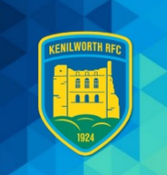
25th August 2026
Former Players & President’s Lunch
Saturday 3rd October 2026
Dear Member,
I would like to welcome you back for our 1st lunch of the season on Saturday 3rd October 2026 v’s Dudley Kingswinford.
The ticket price £30 includes ground entry and a three-course meal with wine. Please note guests are very welcome
- Bar opens 11.30
- Game kick off 2.15pm
I would be grateful if you could reply via email or phone, or purchase your ticket on line via the QR code or link below. If you are organising a table please let me know.

https://buytickets.at/krfc/2373960
Any questions just contact me directly
- Peter.lindsay@hotmail.co.uk
- 07789 753345 (call, txt or whatsapp)
I look forward to greeting you at the club on Saturday 3rd October
Yours faithfully,
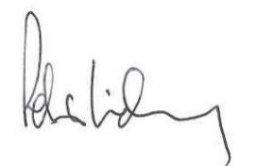
Peter Lindsay. Hon. Secretary.
07789 753345

